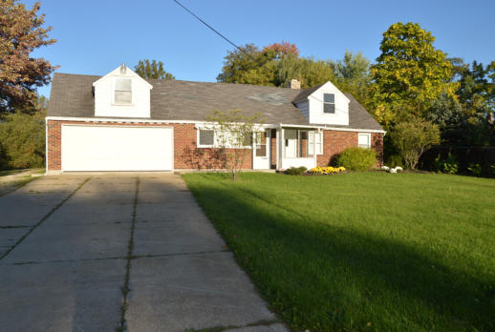

Le Radici cordially invites you to attend an
Open House
Come see what we did with our remodeling efforts!

Date:
March 29, 2025
Time:
9:00AM – 11:00AM

Refreshment and Snacks will be served.
3411 Wyoga Lake Rd.
Cuyahoga Falls, OH 44224

