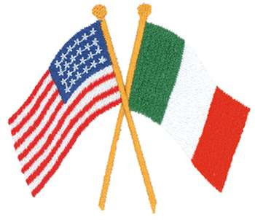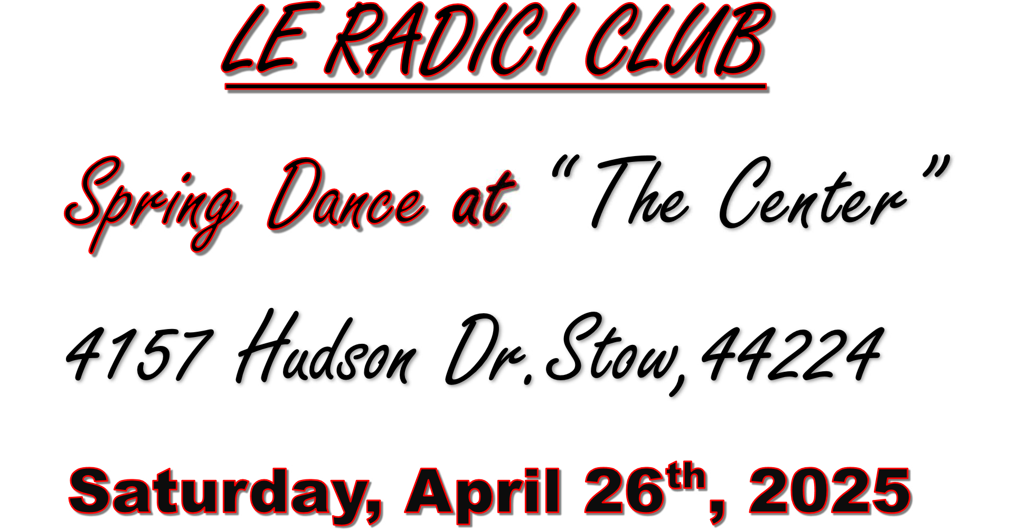

**Cash Bar - $65 per person**

**6:00 PM – 7:00 PM Appetizers & Cocktails**

**7:00 PM: Dinner - 8:00 – 11:30 PM: Dancing**

Menu: Appetizers During Cocktail Hour

Salad, Bread and Butter

Italian Baked Chicken

Beef Tenderloin, Lasagna

Fresh Green Beans and More….

Homemade Desserts and Cassata Cake!!!

Music by: I Campagnoli

of Cleveland, Ohio

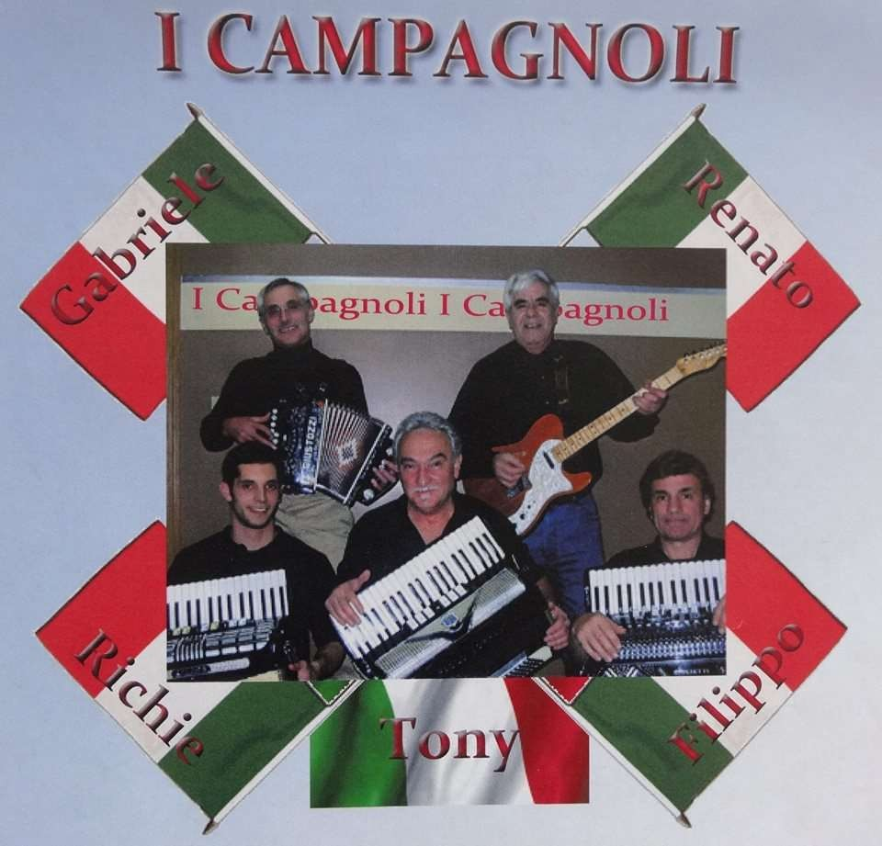

For Tickets call or text…. Virginia Cruickshank 330-990-6971

or Kim Ricci 330-352-4157 Cash, Check or Charge.